NEW COURSE: ANTH 369 B: Special Studies in Anthropology /
JSIS 485 C: Special Topics in Southeast Asia

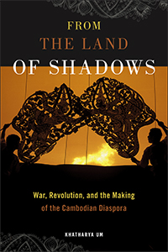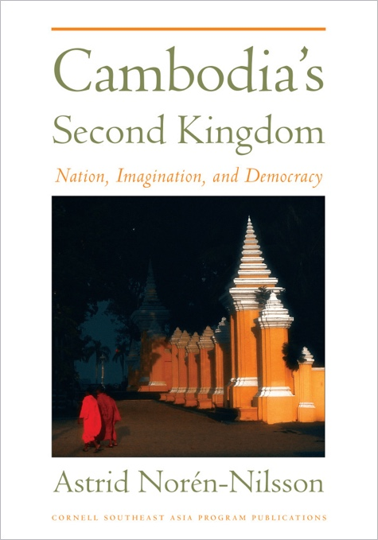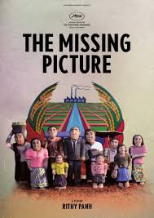

Cambodia: History, Politics, Ethnography
Professor Jenna Grant

Monday & Wednesday, 3:30-5:20pm
Denny Hall (DEN) 112
5 credits

This course explores current themes in the history, politics, anthropology, and cinema of Cambodia and its diaspora. We focus on colonization and decolonization; on Cold War legacies and erasures; and on memory and poetic imagination. The course includes analysis of film, audiovisual media, and archival documents in the UW Library Southeast Asia collections, and an advocacy project related to Khmer language studies.

DEPARTMENT OF ANTHROPOLOGY / JACKSON SCHOOL OF INTERNATIONAL STUDIES / SOUTHEAST ASIA CENTER
AUTUMN QUARTER 2017

