African Studies
Spring 2020
Course List

Africa Courses
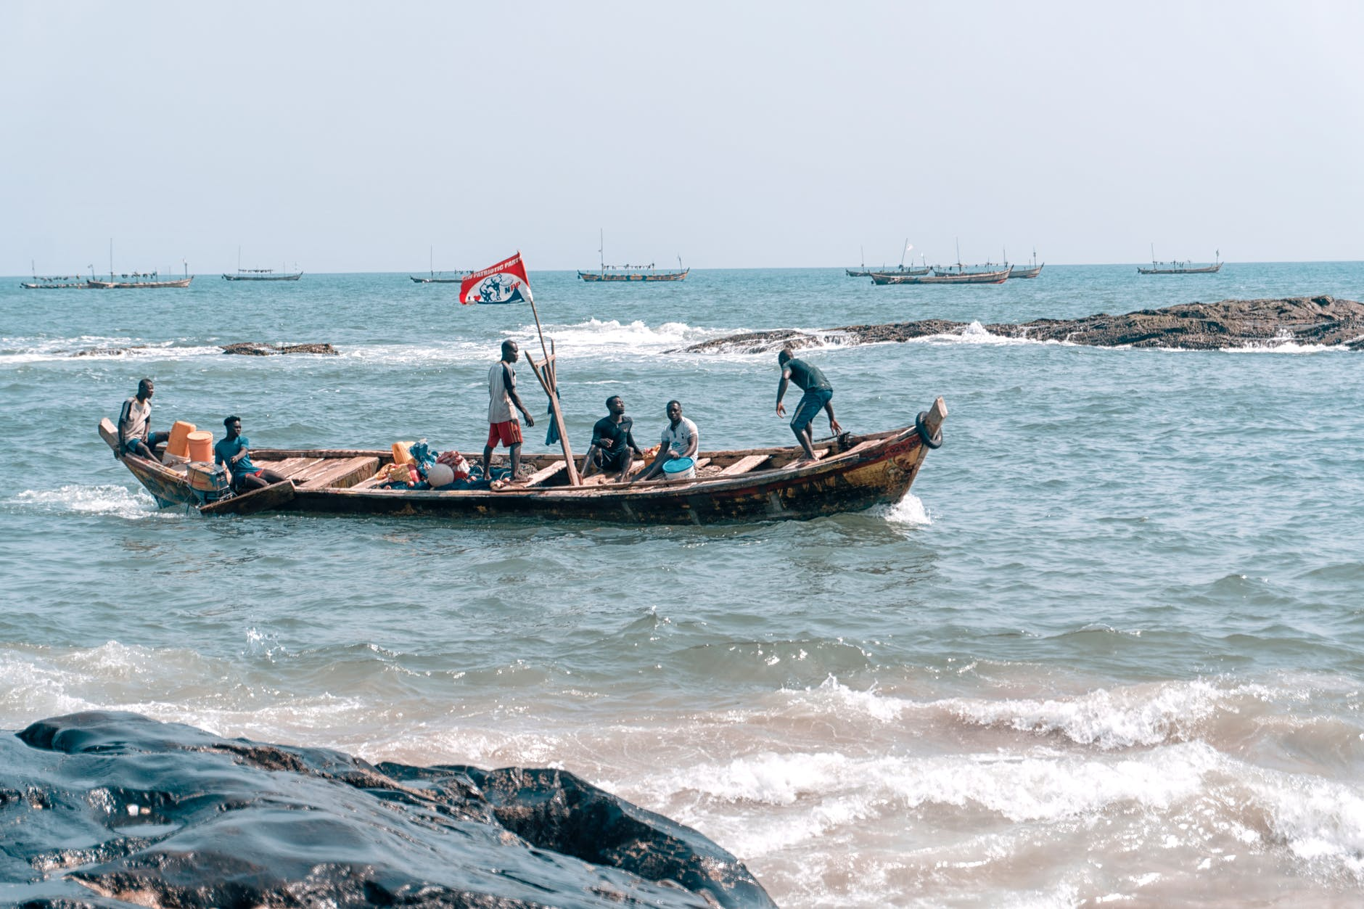

JSIS A 362 POL ECON OF AFRICA | (I&S,DIV)
15635 A 5 WF 1230-220 GLD 436

Focuses on the political economy of governance, development, and conflict in sub-Saharan African countries since independence. Explores the political and economic choices made by Africa's colonial and post-colonial regimes and connects them to current events in sub-Saharan Africa.

ANTH 413 MOD MIDEAST & N AFR | (I&S)
20918 A 5 TTh 130-320 RAI 116 Ege,Gozde B

Presents an anthropological perspective on social/cultural aspects of contemporary Middle East and North Africa. Explores how anthropologists examine key issues in region including identity, politics, economics, religion, and conflict. Considers how ethnographic representations challenge assumptions about people's politics of region and elucidate contemporary manifestations of local, national, regional, and global power

ARCHY 212 ANCIENT EGYPT ARCHY | (VLPA/I&S)

10456 A 5 MW 330-520 KNE 210 Selover,Stephanie

10457 AA QZ Th 130-220 DEN 403

10458 AB QZ Th 230-320 DEN 403

10459 AC QZ Th 330-420 DEN 403

10460 AD QZ Th 430-520P DEN 403

Survey of the archaeology, art, and architecture of ancient Egypt from the prehistoric cultures of the Nile Valley (c. 10,000 BCE) until the end of the New Kingdom (c.1000 BCE), exploring Egyptian gods, divine kings, pyramids, temples, mummification, society, government, religion, medicine, magic, sex, childbirth, and death.

GEOG 180 INTRO TO GLOBAL HLTH | (I&S)

14717 A 5 TTh 330-450 KNE 120 Gloyd,S

14718 AA QZ M 930-1020 SMI 107

14719 AB QZ W 1030-1120 SMI 107

14720 AC QZ M 1030-1120 SMI 107

14721 AD QZ M 1030-1120 SMI 115

14722 AE QZ M 1130-1220 SMI 107

14723 AF QZ T 230-320 SMI 107

14724 AG QZ M 330-420 SMI 107

14725 AH QZ W 930-1020 SMI 107

14726 AI QZ W 1030-1120 SMI 115

14727 AJ QZ W 1130-1220 SMI 107

Provides an introduction to global health, including: the burden and distribution of disease and mortality; the determinants of global health disparities; the making of global health policies; and the outcomes of global health interventions.

HSTAFM 151 AFRIC ERA SLAVE TRAD | (I&S,DIV)
15040 A 5 TTh 300-450 DEN 259 Smallwood, Stephanie

Explores the African past from c. 1400 through the end of the nineteenth century. Uses the emerging evidence of historical, linguistic, and archaeological analysis to think critically about lingering notions that Africa and its peoples are static and unchanging, primitive and simple, and best understood in terms of racial difference.

HSTAFM 490 AFRICA & MID EAST | (I&S)
15042 A 5 MW 330-520 JHN 175 Haddad-Fonda, Kyle

COURSE WILL BE HSTAFM 278, MODERN NORTH AFRICA.
Examines special topics in African and Middle Eastern history.

JSIS B 337 COLLECTIVE VIOLENCE | (I&S,DIV)
15683 A 5 to be arranged Chirot, Daniel

Comparative study of how and why genocides have occurred in modern times. Examines how ethnic, religious, and nationalist conflicts have sometimes led to violent conflict, and how political leaders and governments have mitigated or exacerbated them, sometimes engaging in state sponsored mass killing. Offered: jointly with POL S 337.

POL S 371 GLOBL CRIME & CORRUP | (I&S)

18763 A 5 TTh 830-950 KNE 220 Long,J

18764 AA QZ F 830-920 BLD 392

18765 AB QZ F 830-920 BLD 286

18766 AC QZ F 930-1020 BLD 392

18767 AD QZ F 930-1020 BLD 286

18768 AE QZ F 1030-1120 BLD 286

18769 AF QZ F 1130-1220 FTR 106

18770 AG QZ F 1130-1220 BLD 392

18771 AH QZ F 1230-120 BLD 392

We examine sources & outcomes of illicit behavior within firms, governments, and organizations at local, national, & international levels; investigating the psychological, cultural, political, and economic sources of crime/corruption; and explore these dynamics within businesses, bureaucracies, gangs, mafias, cults, and pirates. Case studies include India, US-Mexico drug trade, piracy, doomsday cults, Sicilian mafias, Nazi drug abuse, & Dark Web. Recommended: POL S 203, POL S 204, or POL S 270; or JSIS 123, JSIS 200, JSIS 201, or JSIS 222; or equivalent. Offered: jointly with JSIS B 371.
POL S 385 WORLD FOOD POLITICS | (I&S/NW)
18773 A 5 TTh 1130-1250 BAG 154 Litfin, K

18774 AA QZ W 930-1020 FTR 106

18775 AB QZ W 1030-1120 FTR 106

18776 AC QZ W 1130-1220 ECE 026

18777 AD QZ W 1230-120 JHN 022
Investigates the intersection of globalization and food politics, the pivotal role of petroleum in the world food system, and the commodity chains for some foods. Includes an optional service learning component. Offered: jointly with ENVIR 385.

African Diaspora Courses

GWSS 489 BLACK CULTL STUDIES | (I&S)
14841 A 5 MW 1030-1220 CMU 104 Johnson,Marcus

Examines how images of blackness have been (re)constructed through identity formation and entrenched inequality. Topics include black women's bodies, black men's bodies, blackface minstrelsy, black queer studies, black power, and black hybridities.

ANTH 479 ADV TOPICS MED ANTH
10339 A 5 MW 830-1020 SAV 156 CLARK,H Open 0/ 40

SPECIAL TOPICS IN MED ANTH: ANTHROPOLOGY OF BEAUTY

AES 462 COMPAR RACE RELATNS | (I&S,DIV)
10194 A 5 MW 130-320 LOW 101 Nguyen,L

Race and ethnicity as factors of social differentiation in a number of Western and non-Western societies in Europe, Africa, Asia, and the Americas.

AES 489 BLACK CULTL STUDIES | (I&S)
10195 A 5 MW 1030-1220 CMU 104 Johnson, Marcus

Examines how images of blackness have been (re)constructed through identity formation and entrenched inequality. Topics include black women's bodies, black men's bodies, blackface minstrelsy, black queer studies, black power, and black hybridities. Offered: jointly with COM 489/GWSS 489.

AFRAM 150 INTRO AF AM HISTORY | (I&S)
10202 A 5 MW 830-1020 LOW 101 Sisay,Brukab

Introductory survey of topics and problems in African American history with some attention to Africa as well as to America. Basic introductory course for sequence of lecture courses and seminars in African American history. Offered: jointly with HSTAA 150.

AFRAM 330 MUS & FKLR BLK SOC | (VLPA)
10203 A 5 TTh 230-420 AND 008 Sisay, Brukab

Focuses on cultural expressions created by people of African descent in the Unites States in
the twentieth century, with an emphasis on music, folklore, dance, and humor.

AFRAM 337 MUS & SOC CHANGE | (VLPA/I&S,DIV)
10204 A 5 TTh 130-320 OUG 136 Retman,Sonnet H.

Focuses on popular music, shifting formations of race and identity and social change in various cultural, historical, and political contexts. Explores popular music as a tool for social change, a vehicle for community-building and a form of political and aesthetic expression.

AFRAM 498 SPEC TOP AFRAM STDY | (I&S)

10206 A 5 TTh 1030-1220 THO 334 Pittman,LaShawnDa L.
SPECIAL TOPICS: HEALTH DISPARITIES IN AFRICAN AMERICAN WOMEN

JSIS B 441 FORCED MIGRATIONS | (I&S,DIV)
15711 A 5 MW 130-320 THO 325 Friedman, K

JOINTLY OFFERED WIT JSIS B 541
Provides an interdisciplinary understanding of the causes, characteristics, and
consequences of forced migration experiences across the global system. Explores how international policy makers, humanitarian workers, and scholars have constructed forced migration as a problem for analysis and action, including some of the ethical dilemmas involved.

DANCE 240 STREET & CLUB DANCE | (VLPA/I&S)

21223 A 3 TTh 1230-220 MNY 267 Tirrell,Dani

Studio and lecture/discussion about dances that originated and continue to evolve fro Hip Hop culture. Addresses the aesthetic, social, and cultural differences between styles rooted in clubbing/battling/cyphering/sessioning. Exposes students to legacy of the forms

DANCE 275 AFRO-LATINX DANCE | (VLPA, DIV)
12939 A 3 TTh 230-420 DEN 212 Rojas-Stewart Monica

Explores dance traditions among various Afro-Latinx cultures, the history, politics and the role of performance in imagining, constructing and projecting identities. Through dance practice, readings and discussions students will investigate participatory vs. presentational performance and dance as a tool for activism within the larger social, political, and cultural contexts in which these traditions emerged, are practiced and continue to evolve. Recommended: at least one quarter of dance technique, or three months of community-based dance classes.

DANCE 287 CAPOEIRA | (VLPA)
12941 A 2 MW 430-620P MNY 265

Practice-based instruction in the Afro-Brazilian art of capoeira, including movement, music, culture, history.

ENGL 319 AFRICAN LITS | (VLPA,DIV)
13875 A 5 MW 230-420 SIG 224 Chrisman, Laura H

Introduces and explores African literatures from a range of regions. Pays particular attention to writings connected with the historical experiences of colonialism, anti-colonial resistance, and decolonization. Considers the operations of race, gender, nationhood, neocolonialism, and globalization within and across these writings.

Language Courses
SWA 103 BASIC SWAHILI

19844 A 5 MTWThF 1130-1220 SAV 157 Waita, J

19845 B 5 MTWThF 1230-120 SAV 157 Waita, J

PORT 201 INTERMEDIATE PORT | (VLPA)
18820 A 5 MTWThF 930-1020 LOW 115
18821 B 5 MTWThF 1130-1220 LOW 115

PORT 301 ADVANCED PORT | (VLPA)
18822 A 5 MTWThF 1030-1120 LOW 115 Viana Da Silva, Eduardo

SWA 203 INTERMED SWAHILI | (VLPA)

19846 A 5 MTWThF 930-1020 SAV 157 Waita, J

ARAB 203 INTERMED ARABIC | (VLPA)
10355 A 5 MTWThF 930-1020 DEN 113 Ahmed,K

FRENCH 201 INTERMEDIATE FRENCH | (VLPA)
14540 A 5 MTWThF 930-1020 LOW 222 Meyer,Hedwige

FRENCH 202 INTERMEDIATE FRENCH | (VLPA)
14542 A 5 MTWThF 930-1020 SAV 138 Collins,Helene V.

FRENCH 203 INTERMEDIATE FRENCH | (VLPA)
14547 C 5 MTWThF 130-220 THO 235
FRENCH 301 ADVANCED FRENCH | (VLPA)
14548 A 5 MW 130-320 SIG 230
FRENCH 302 ADVANCED FRENCH | (VLPA)
14550 A 5 MW 1030-1220 CMU 228 Giachetti,Lorenzo
F 1030-1120 SAV 136 Giachetti,Lorenzo
14551 B 5 MW 1230-220 SAV 156 Giachetti,Lorenzo
F 1230-120 SAV 156

