9/20: JSIS all-school meeting notes

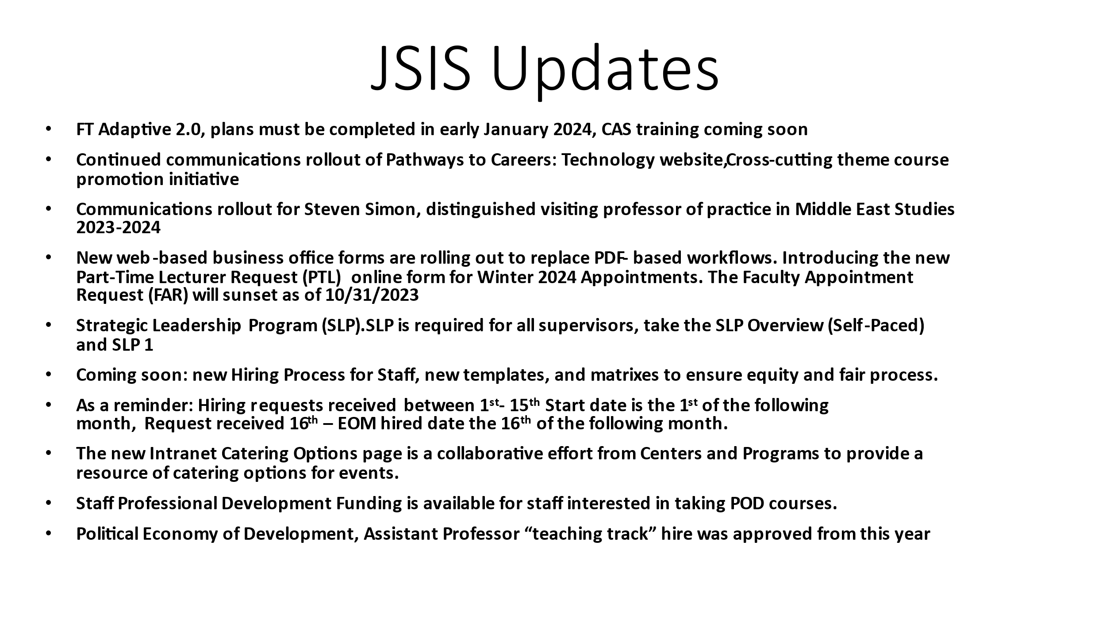

Danny:

- All-school meetings to continue in the future.
- Goals for this academic year are making JSIS the best place to work on campus, having strategic plan, serving students, cultivating relationship with CAS, and continuing the process of financial transformation.

Lacey:

- Strategic planning update: value worksheet completed, committee working on reviewing. Third worksheet coming soon. After that: risk assessment, action plan. Timeline slightly changed. Finalized documents and strategic map to be rolled out in late Fall. Celebration Reception in the Fall.

Danny:

- JSIS is the largest and most complicated division at CAS. The message out of CAS is that the College itself is in a period of stasis, meaning it does not feel capacity to grow, but it’s not shrinking either. Numbers expected to stay stable. Part of why we are going through strategic planning is so that we can direct the way JSIS grows before numbers start shrinking.
- JSIS numbers: 44 faculty, 45 staff members, which makes JSIS a very large institution. Running like a large institution is not JSIS’s forte. About 20% of CAS staff works at JSIS.

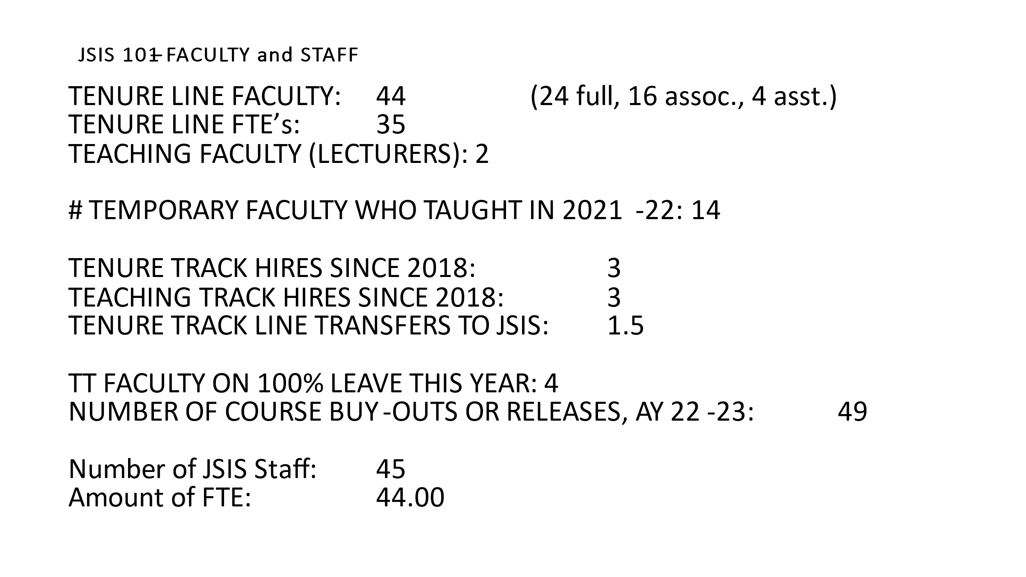

- GOF funds to decrease in FY 24. Not a crisis as we have access to other funds (EOF, endowments). Very complex financial situation that needs careful management in the next few years to make it sustainable and avoid being in a position of being told to cut expenses in order to save funds. That won’t happen if we are intentional now.
- Strategic planning will make sure that the financial administration at JSIS is supported in being efficient.
- CAS to not give a specific ideal number or formula for student enrollment increase. This is frustrating but also good - we can define terms while showing that we are taking the issue very seriously and that we are making clear efforts to get the numbers up.
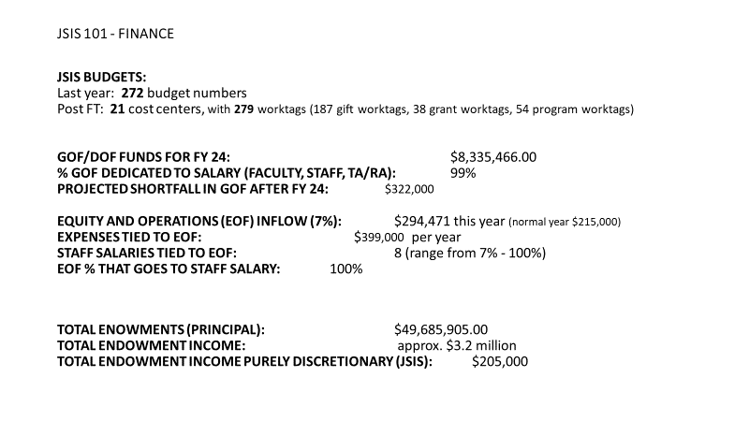

- On student growth: comment from Jesús - it might be time to add a student recruitment position. Danny: the need is real, and strategic planning will determine how to make it happen while making things more efficient.
- Issue of 21% of grad classes having 1-4 students (see slide).

