PANEL DISCUSSION
THIS IS A LECTURE TITLE

LECTURER NAME

TITLE/POSITION
Lorem ipsum dolor sit amet, in assentior percip- itur vim, percipitur delicatissimi eu his. Delicata signiferumque mea et. Dolor detracto albucius ius.

LECTURER NAME

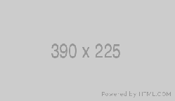
TITLE/POSITION
Lorem ipsum dolor sit amet, in assentior percip- itur vim, percipitur delicatissimi eu his. Delicata signiferumque mea et. Dolor detracto albucius ius.

LECTURER NAME

TITLE/POSITION
Lorem ipsum dolor sit amet, in assentior percip- itur vim, percipitur delicatissimi eu his. Delicata signiferumque mea et. Dolor detracto albucius ius.



WEEKDAY, DATE, 2019 LOCATION DETAILS
This event is free and open to the public.

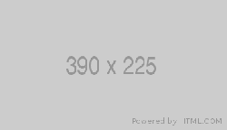
RSVP: https://artsci.washington.edu/ SPONSORS

For more info: https://artsci.washington.edu/ | 206.123.4567 | jsis.washington.edu/events
To request disability accommodation, contact the Disability Services Office at least ten days in advance at: 206.543.6450/V, 206.543.6452/TTY, 206.685.7264 (FAX), or dso@uw.edu

