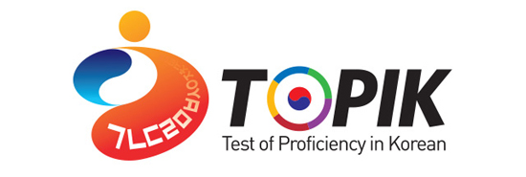

■ The 57th TOPIK will be administrated by the Consulate General of the Republic of Korea in Seattle. All overseas Koreans and foreigners who are preparing to study or work in Korea are encouraged to take the test.

■ Test Registration
- Applicant Eligibility: Overseas Koreans and foreigners who are not native Korean language speakers.
- Date & Schedule: April 14, 2018 (Sat) 9:30-16:00
Division | Period | Assessment Skill | Time
TOPIK 1(Beginner) | 1 | Listening, Reading | 09:40~11:20 (100 min)
TOPIK 2(Intermediate, Advanced) | 1 | Listening, Writing | 12:50~14:40 (110 min)
TOPIK 2(Intermediate, Advanced) | 2 | Reading | 15:10~16:20 (70 min)
※ Please enter the test room at least 30 minutes before the start of the test.

■Test Sites
- Mechanical Engineering Building(MEB), University of Washington

■Registration Methods - Application form: The application form can be downloaded from the homepage of the Consulate General of the Republic of Korea (http://overseas.mofa.go.kr/us-seattle-en/index.do)
- Application(testing) fee:
TOPIK 1 | $35
TOPIK 2 | $40
*The application fee is not refundable
- Please send the application form and application fee(check payable to “Korean Consulate General”) to the address below.

- Registration deadlines: January 30, 2018(Tue)

- Address & contacts
: Consulate General of the Republic of Korea
2033 6th Ave. #1125, Seattle, WA 98121
(seattleedu@mofa.go.kr / 206-441-1011~4 Ext.301)

* The TOPIK in Oregon(Portland) will be held on May 19, 2018

